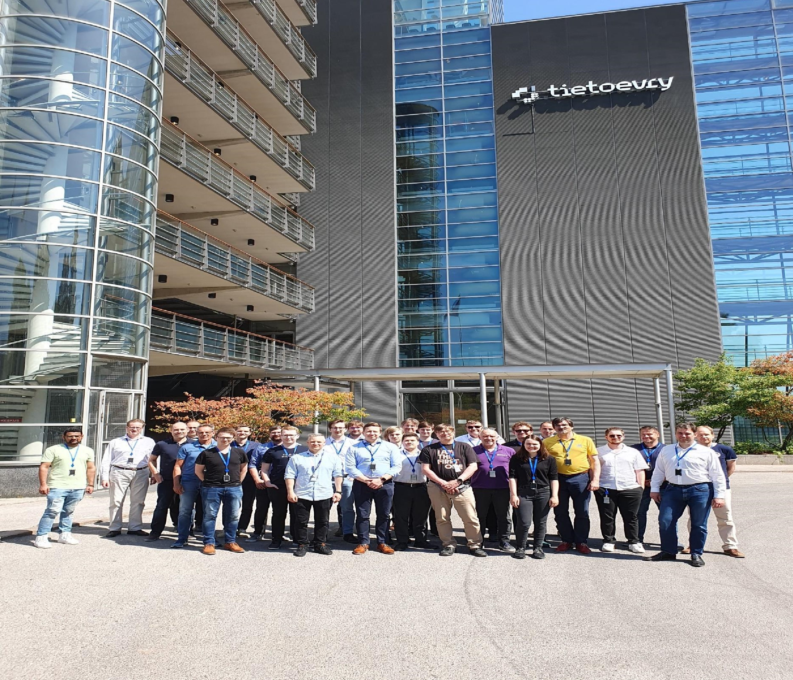

FEBRUARY 18

2024

**T**

**ietoevry India pvt ltd**

**Authored by:**

**Medhini Shetty**

**AGILE**

**METHODOLOGY**

**AND BANKING**

**DOMAIN**

**Agile Methodology**

Agile methodology is an iterative approach to software development, emphasizing flexibility, collaboration, and customer feedback. It breaks down projects into small increments. Which makes it easy to implement the product.

Whenever a product owner comes with his/her requirements the development team will collect epics and stories from the product owner which is then converted to task.

**Epic:** In Agile methodology, an "epic" refers to a large body of work that can be broken down into smaller tasks or user stories.

**Story:** In Agile methodology, a "story" (or user story) is a small, manageable unit of work that represents a specific requirement or feature from the perspective of an end user.

**Story format:** as a <user>

I want to<perform action>

So that I can<see result>

Here the epics are converted into stories by product owner and stories are converted to task by team members.

**Task:** In Agile methodology, a "task" is a specific unit of work that needs to be completed to fulfill a user story

To estimate the time or scale of completing the project we use the term called **sprint (**estimation of work). It is expressed in terms of **Story point.**

In a project development team, there are three roles called Product owner, Scrum master and Scrum team or team members.

**Product owner:** A person who comes to a development team with the requirements and stories.

**Scrum master:** Ensure the needs are met

**Scrum team:** works on the user requirement and stories.

Process followed to implement the Project:

1. Release Plan
2. Sprint Planning
3. Daily Standup

4) Sprint Review

5) Retrospective

1. Sprint Review
2. Retrospective

For better understanding we practically implemented the above topics by taking a **Banking domain** as a case study and did a Brocher for a bank company.

In our project to develop a banking application, we embraced Agile methodology to ensure flexibility, collaboration, and continuous feedback. The process started with the Product Owner presenting requirements, which were then converted into epics and

stories. The Scrum Team, consisting of developers and designers, further converted the stories into actionable tasks. We estimated the work using story points to plan our sprints, each lasting two weeks. Throughout the project, the Product Owner provided feedback and prioritized features, while the Scrum Master facilitated communication and removed obstacle. Our process included a Release Plan to outline milestones, Sprint Planning to determine goals for each sprint, Daily Standup (15 min) meetings for coordination, Sprint Reviews to showcase completed work, and Retrospectives to reflect on improvements. By following this structured approach, we successfully delivered a brochure for the bank company, demonstrating our progress and iterating based on other team’s feedback.